**WEEK 10**

# Write sub queries to retrieve information from the created database

**Subqueries:**

A Subquery (Nested query) is a query inside another SQL query. It is embedded within the WHERE clause.

The inner query is executed first. It gives the result to the outer query. The outer query's result is based on the result of the inner subquery.

Subqueries can be used with operators like =, <, >, >=, <=, IN, BETWEEN, etc.

Subqueries must be enclosed within parentheses ( ).

**Table: student**

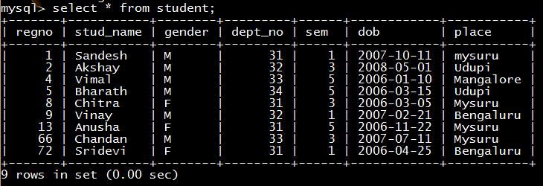

**Table: score**

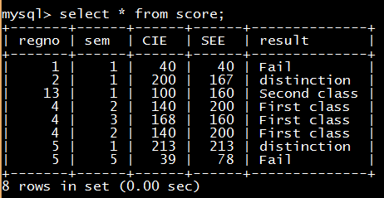

**MULTIPLE ROW SUBQUERY**

**mysql>**select * from student where regno in (select regno from student where place =’Mysuru’;

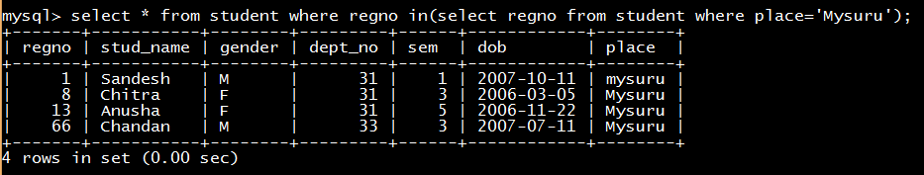

**SINGLE ROW SUBQUERY**

**mysql>**select  * from  score  where  SEE = ( select max(SEE) from score);

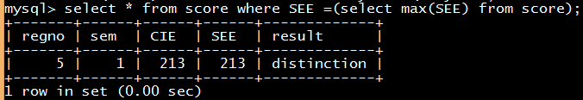

**EXISTS**

**mysql>**Select * from student st where exists ( select * from score s where st.regno = s.regno);

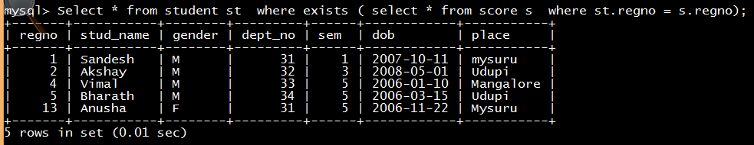

**NOT EXISTS**

**mysql>**Select * from student st where not exists ( select * from score s where st.regno = s.regno);

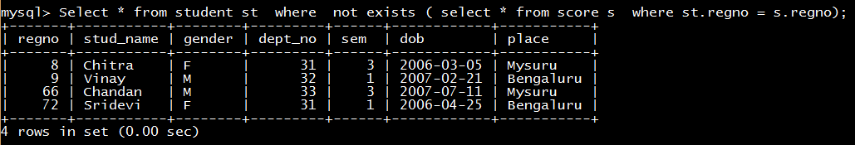

**Subqueries with ALL, ANY**

**mysql>**select regno, name, gender from student regno > all (select regno from score);

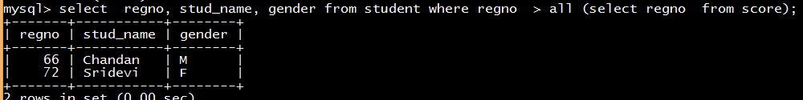

**mysql>**select regno, name, gender from student regno > any (select regno from score);

